**Feeling Safe – All The Time!**



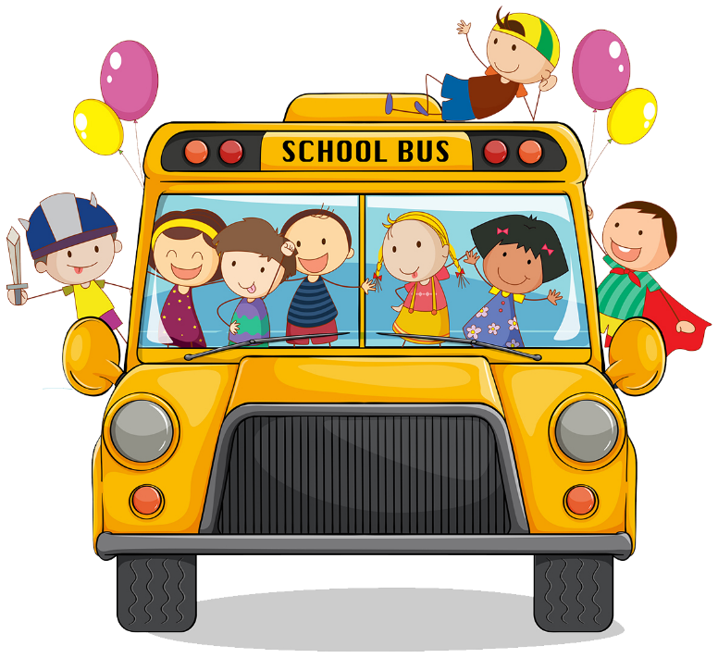

**A Safeguarding Policy for the Children of**

**Armoy Primary School**

**Do You Feel Safe?**

It’s really important to all the staff of Armoy Primary School that you feel safe in school and at home, no matter who you are with.

**What Happens If You Don’t Feel Safe?**

MC900438229[1]There is **nothing** too big or too small to talk about. If you do not feel safe or you are unhappy about any situation, it is very important that you talk to someone that you know you can trust. If you are not sure about who you can share a problem with, here are some ideas:

* Mum/Dad or Carer
* Grandparent, older Brother or Sister
* Mrs Kane, Mrs Wall or Mrs Barr (teachers responsible for Child Protection)
* Your class teacher
* Mrs Steele

BD18225_If you don’t want to talk to someone you know, you can always phone Childline for advice.

**Childline: 08001111**

It does not cost anything to call this number.

**If I Tell A Teacher, Will They Keep It A Secret?**

If you share a problem or issue with a teacher, they cannot promise to keep it a secret. However, you can be sure that only the people who really need to know will be told. If the teacher tells someone else, it is because this is the best thing to do to help you.

You can trust any Staff member in our school.

**Only the adults who really need to know will be told!**

**What Are the Things That I can Talk About?**

MC900438251[1] You can talk to any teacher or adult in our school about anything you are worried about or afraid of.

It is very important to tell a trusted adult if

anything happens to you that makes you

Feel uncomfortable or that you know is wrong.

It is also very important to tell someone if you think something bad may be happening to a friend.

**What If I’m Told to Keep It a Secret?**

If someone you know has asked you to keep a secret about something that is upsetting you or worrying you, it’s very important that you do not do this.

Some secrets like birthday presents are good secrets to keep. If you are ever told to keep something a secret that does not make you feel good, do not keep it. **Only keep a good secret.**

**What Happens If I Can’t Wait Until I Come into School Tomorrow?**

If a scary situation happens outside school and you are worried that you or a member of your family is going to get hurt, you should get the help of an adult or neighbour who you can trust. Then tell a Teacher when you get into school the next day.

**Remember these things are NOT your fault and you are NOT** MC900071184[1]**alone**